Assignment 5

HTML file for Physics department

PRN : 2018BTECS00026

Github Link : <https://github.com/rohitopal/PL3-assignments/tree/master/Assignment%205%202018BTECS00026>

These are some screenshot of the web page :

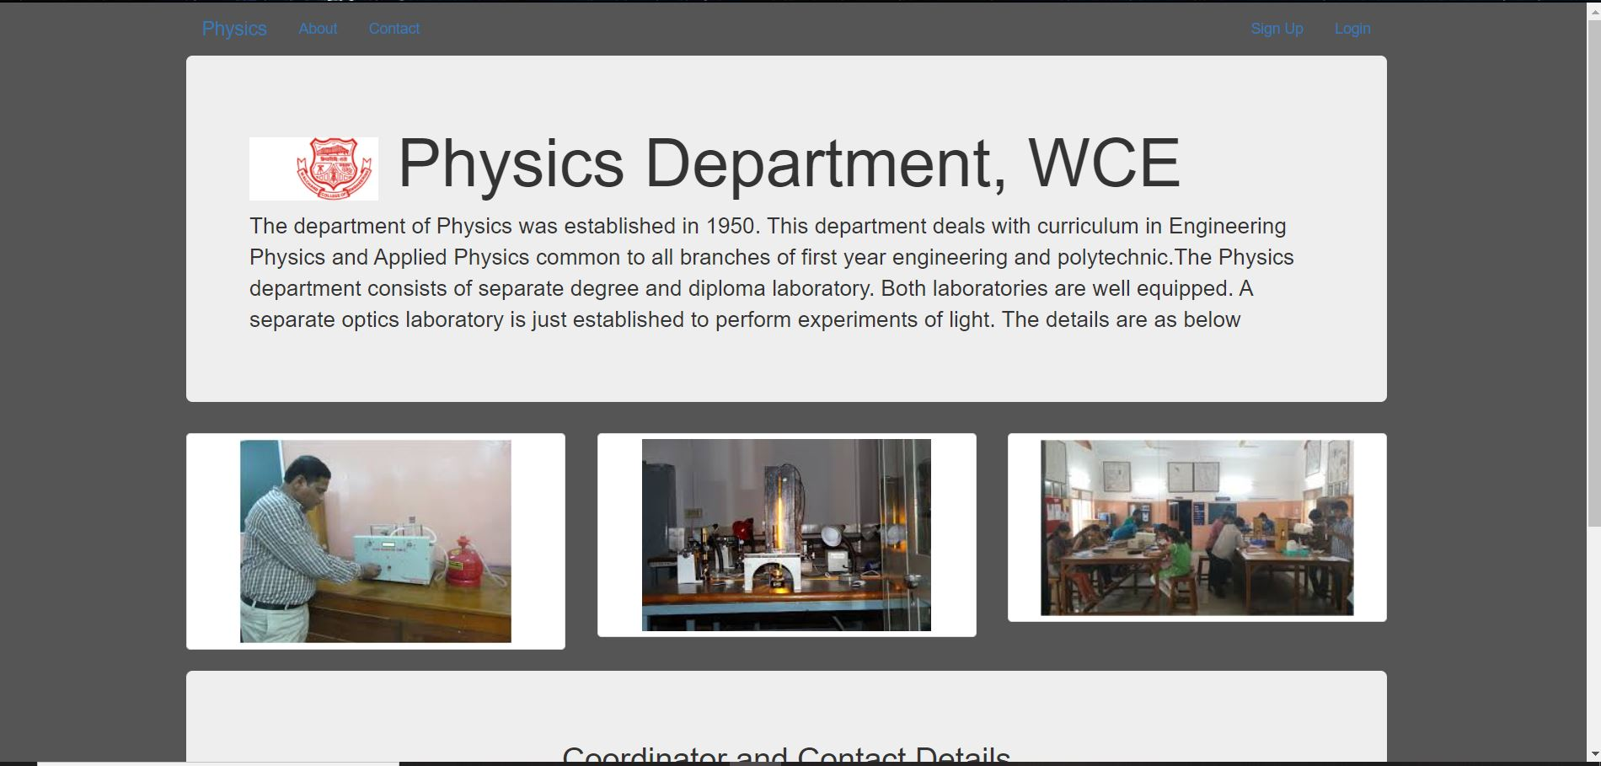

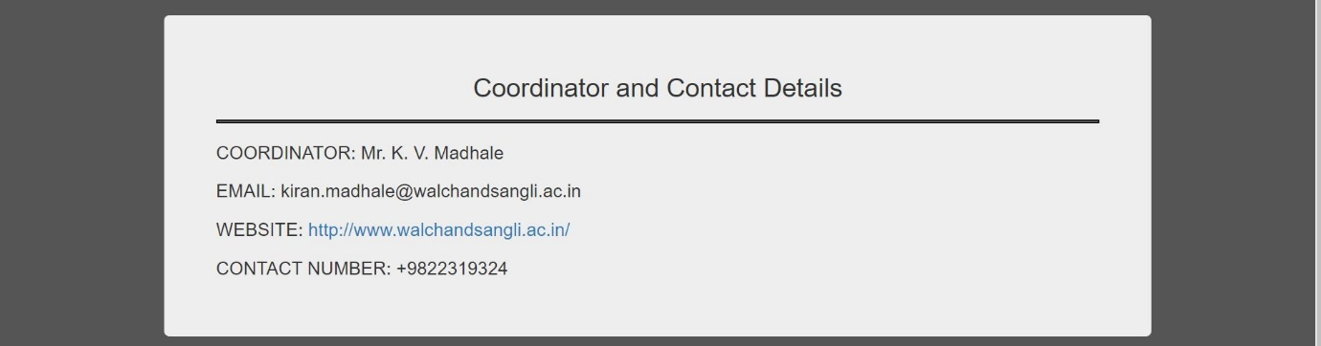

The code for the given web page is present in the repository and in the submitted folder.

Thank You !